Abstract

This is an implementation of the Dynamic Time Warping algorithm for the Pure Data programing environment. It’s one of the algorithms for measuring similarity between two temporal sequences that in different speed. In general, Dynamic Time Warping algorithm is to calculate the optimal match ratio between two different signals. The code is able to visualize the original signals and aligned signals. It also applies to random signals.

DTW Algorithm

In general, DTW is a method that figures similarity between two signals and searches the optimal alignment in between. The output of this algorithm processing is a distance value, which means how far the two signals are.

DTW Implementations

Since the target is pure data environment, I present Matlab implementation. The two signals can be given arrays with specific numbers or also be random generated numbers in a certain range. The implementation is based on Wikipedia resource. I couldn’t find the MIT random data from the link, so I created some random integers between 1 and 0 to test. The distance looks fine in every test.

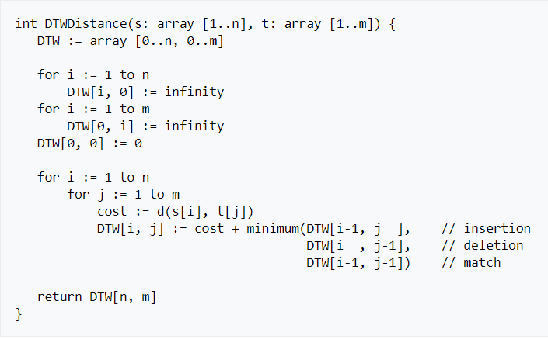

Figure 1. DTW implementation (Wikipedia)

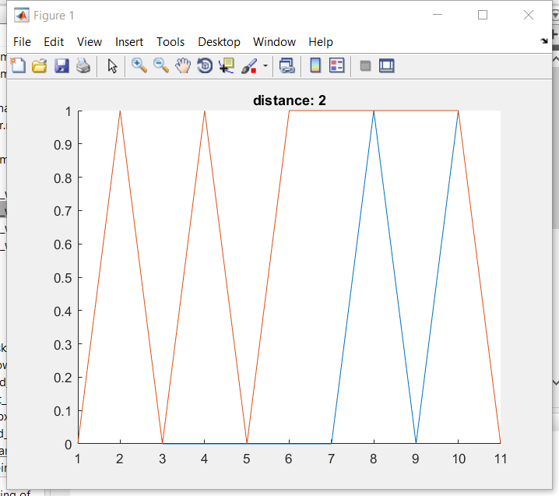

Figure2. DTW with two given signals

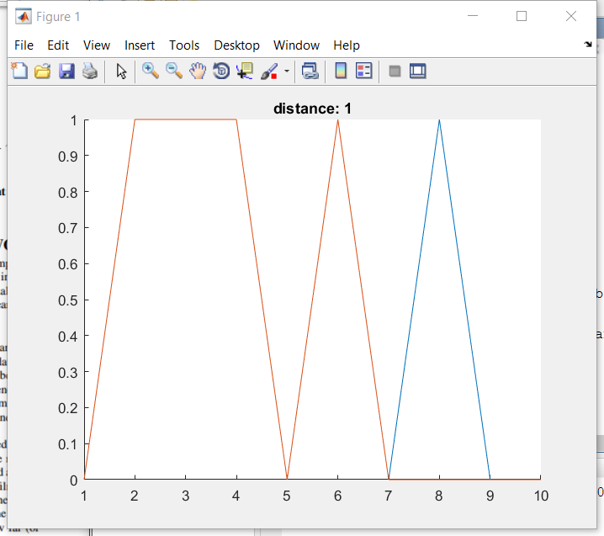

Figure3. DTW with random input signals

Conclusion

The progress was included in the code and figures. The DTW algorithm is able to find the distance between two signals. Since I didn’t find any MIT files that could be download as random input signals, I used “randn” command to create random integers as input signals. It seems fine in the distance calculation. I am confused about this project but I don’t have enough time to work more on it since I have 6 classes, this is the best I can do within limited time. I learned good amount knowledge through the project.